

AP® Physics C
2001 Free response Questions

The materials included in these files are intended for use by AP teachers for course and exam preparation in the classroom; permission for any other use must be sought from the Advanced Placement Program®. Teachers may reproduce them, in whole or in part, in limited quantities, for face-to-face teaching purposes but may not mass distribute the materials, electronically or otherwise. These materials and any copies made of them may not be resold, and the copyright notices must be retained as they appear here. This permission does not apply to any third-party copyrights contained herein.

These materials were produced by Educational Testing Service® (ETS®), which develops and administers the examinations of the Advanced Placement
Program for the College Board. The College Board and Educational Testing Service (ETS) are dedicated to the principle of equal opportunity, and their
programs, services, and employment policies are guided by that principle.

The College Board is a national nonprofit membership association dedicated to preparing, inspiring, and connecting students to college and opportunity.
Founded in 1900, the association is composed of more than 4,200 schools, colleges, universities, and other educational organizations. Each year, the
College Board serves over three million students and their parents, 22,000 high schools, and 3,500 colleges, through major programs and services in
college admission, guidance, assessment, financial aid, enrollment, and teaching and learning. Among its best-known programs are the SAT®, the
PSAT/NMSQT®, and the Advanced Placement Program® (AP®). The College Board is committed to the principles of equity and
excellence, and that commitment is embodied in all of its programs, services, activities, and concerns.

APIEL is a trademark owned by the College Entrance Examination Board. PSAT/NMSQT is a registered trademark jointly owned by the College Entrance Examination Board and the National Merit Scholarship Corporation. Educational Testing Service and ETS are registered trademarks of Educational Testing Service.

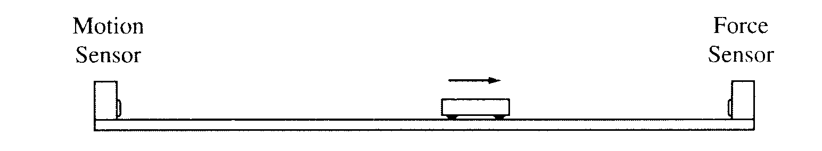

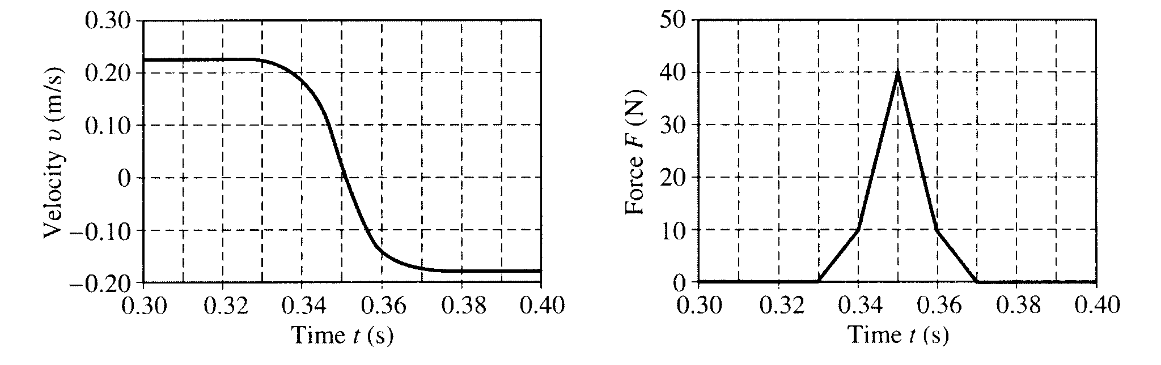
2000M1. A motion sensor and a force sensor record the motion of a cart along a track, as shown above. The cart is given a push so that it moves toward the force sensor and then collides with it. The two sensors record the values shown in the following graphs.
a. Determine the cart's average acceleration between t = 0.33 s and t = 0.37 s.

b. Determine the magnitude of the change in the cart's momentum during the collision.

c. Determine the mass of the cart.

d. Determine the energy lost in the collision between the force sensor and the cart

2000M2. An explorer plans a mission to place a satellite into a circular orbit around the planet Jupiter, which has mass M_{J} = 1.90 x 10²⁷ kg and radius R_{J} = 7.14 x 10⁷ m.
a. If the radius of the planned orbit is R, use Newton's laws to show each of the following.
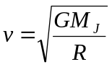i. The orbital speed of the planned satellite is given by

ii. The period of the orbit is given by

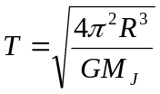
b. The explorer wants the satellite's orbit to be synchronized with Jupiter's rotation. This requires an equatorial orbit whose period equals Jupiter's rotation period of 9 hr 51 min = 3.55 x 10⁴ s. Determine the required orbital radius in meters.
c. Suppose that the injection of the satellite into orbit is less than perfect. For an injection velocity that differs from the desired value in each of the following ways, sketch the resulting orbit on the figure. (J is the center of Jupiter, the dashed circle is the desired orbit, and P is the injection point.) Also, describe the resulting orbit qualitatively but specifically.

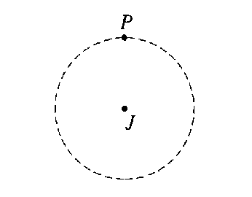i. When the satellite is at the desired altitude over the equator, its velocity vector has the correct direction, but the speed is slightly faster than the correct speed for a circular orbit of that radius.

ii. When the satellite is at the desired altitude over the equator, its velocity vector has the correct direction, but the speed is slightly slower than the correct speed for a circular orbit of that radius.
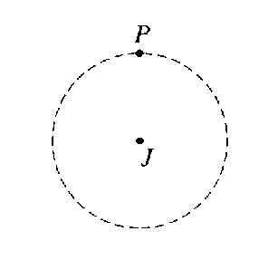
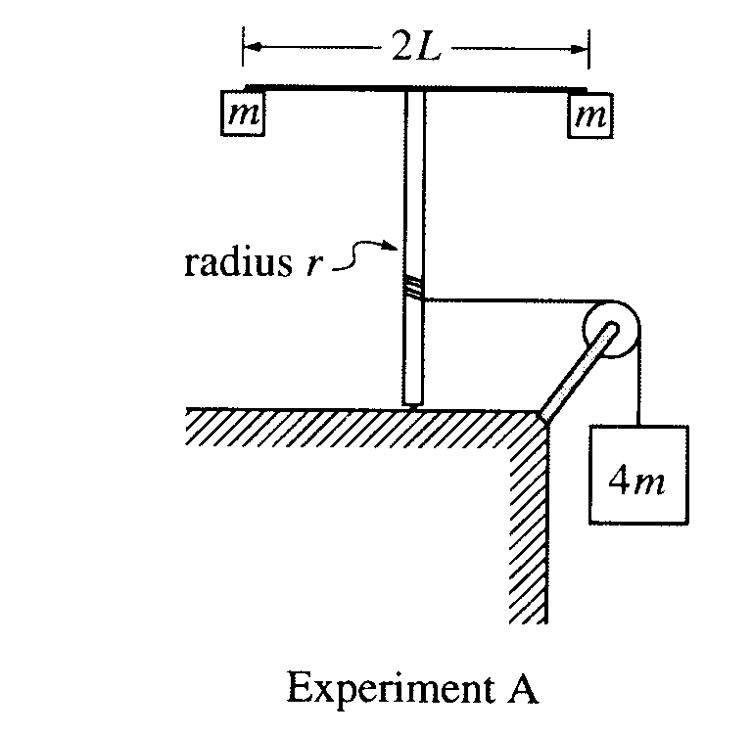
2000M3. A light string that is attached to a large block of mass 4m passes over a pulley with negligible rotational inertia and is wrapped around a vertical pole of radius r, as shown in Experiment A above. The system is released from rest, and as the block descends the string unwinds and the vertical pole with its attached apparatus rotates. The apparatus consists of a horizontal rod of length 2L, with a small block of mass m attached at each end. The rotational inertia of the pole and the rod are negligible.
a. Determine the rotational inertia of the rod-and-block apparatus attached to the top of the pole.
b. Determine the downward acceleration of the large block.
c. When the large block has descended a distance D, how does the instantaneous total kinetic energy of the three blocks compare with the value 4mgD ? Check the appropriate space below and justify your answer.

Greater than 4mgD Equal to 4mgD Less than 4mgD

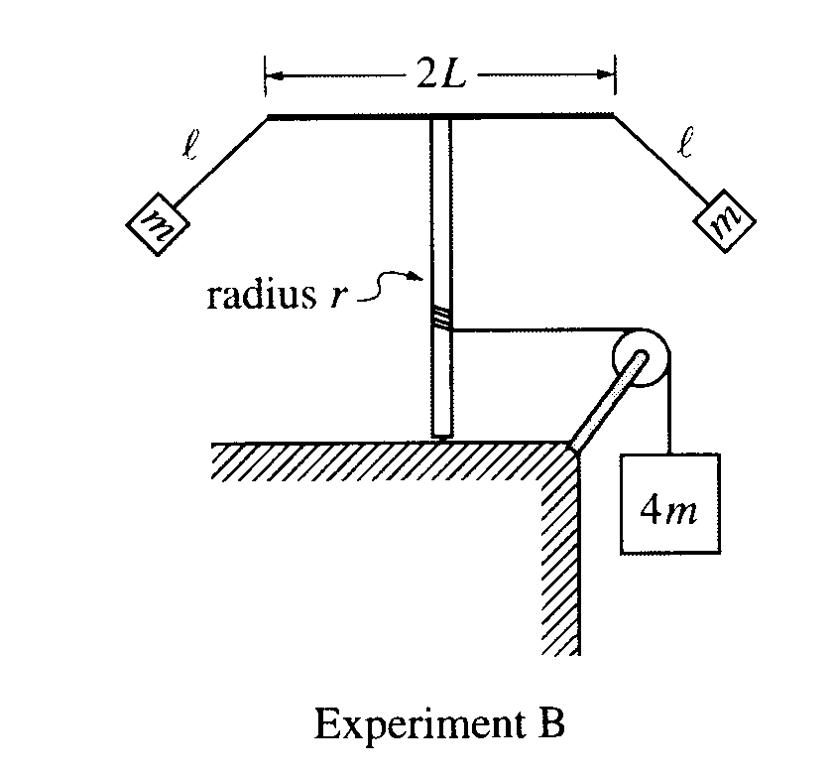
The system is now reset. The string is rewound around the pole to bring the large block back to its original location. The small blocks are detached from the rod and then suspended from each end of the rod, using strings of length l. The system is again released from rest so that as the large block descends and the apparatus rotates, the small blocks swing outward, as shown in Experiment B above. This time the downward acceleration of the block decreases with time after the system is released.
d. When the large block has descended a distance D, how does the instantaneous total kinetic energy of the three blocks compare to that in part c.? Check the appropriate space below and justify your answer.

Greater before Equal to before Less than before

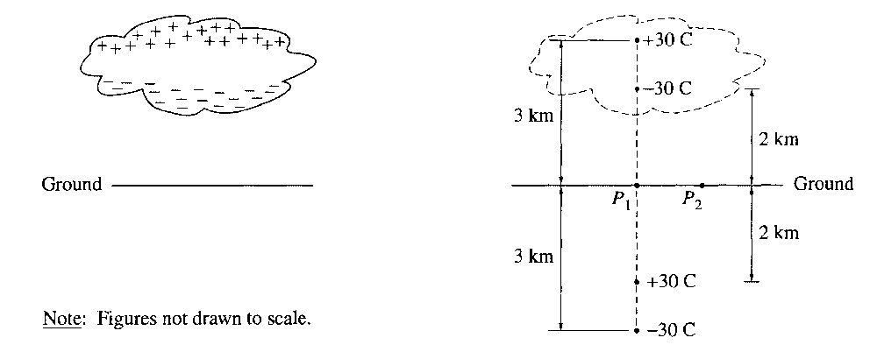2001E1. A thundercloud has the charge distribution illustrated above left. Treat this distribution as two point charges, a negative charge of -30 C at a height of 2 km above ground and a positive charge of +30 C at a height of 3 km. The presence of these charges induces charges on the ground. Assuming the ground is a conductor, it can be shown that the induced charges can be treated as a charge of +30 C at a depth of 2 km below ground and a charge of -30 C at a depth of 3 km, as shown above right. Consider point P₁, which is just above the ground directly below the thundercloud, and point P₂, which is 1 km horizontally away from P₁.
a. Determine the direction and magnitude of the electric field at point P₁.
b. i. On the diagram on the previous page, clearly indicate the direction of the electric field at point P₂
ii. How does the magnitude of the field at this point compare with the magnitude at point P₁? Justify your answer:

Greater Equal Less

c. Letting the zero of potential be at infinity, determine the potential at these points.
i. Point P₁
ii. Point P₂
d. Determine the electric potential at an altitude of 1 km directly above point P₁.
e. Determine the total electric potential energy of this arrangement of charges.

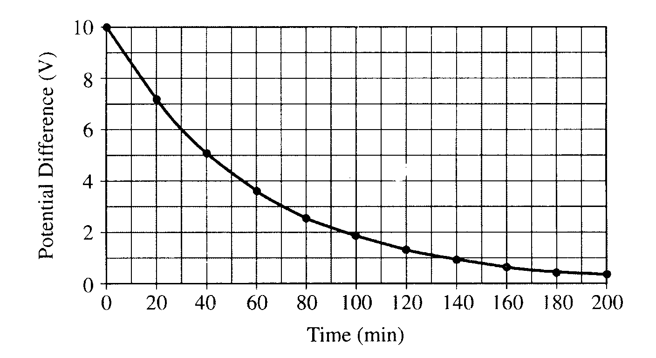
2001E2. You have been hired to determine the internal resistance of 8.0 μF capacitors for an electronic component manufacturer. (Ideal capacitors have an infinite internal resistance - that is, the material between their plates is a perfect insulator. In practice, however, the material has a very small, but nonzero, conductivity.) You cannot simply connect the capacitors to an ohmmeter, because their resistance is too large for an ohmmeter to measure. Therefore you charge the capacitor to a potential difference of 10 V with a battery, disconnect it from the battery and measure the potential difference across the capacitor every 20 minutes with an ideal voltmeter, obtaining the graph shown above.
a. Determine the internal resistance of the capacitor.

The capacitor can be approximated as a parallel-plate capacitor separated by a 0.10 mm thick dielectric with K = 5.6.

b. Determine the approximate surface area of one of the capacitor "plates."
c. Determine the resistivity of the dielectric.
d. Determine the magnitude of the charge leaving the positive plate of the capacitor in the first 100 min.

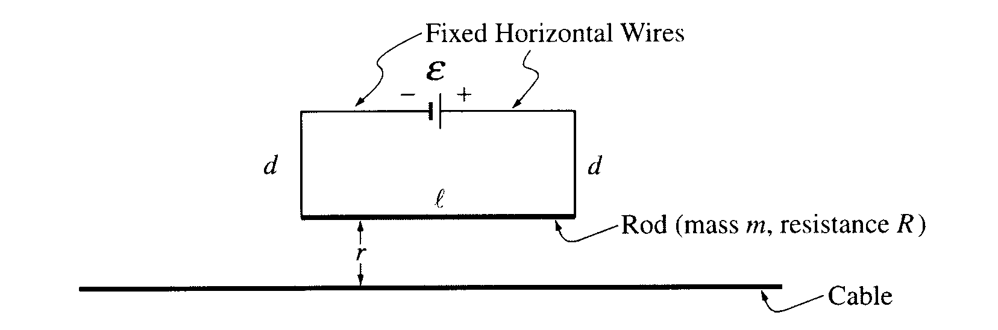
2001E3. The circuit shown above consists of a battery of emf ε in series with a rod of length l, mass m, and resistance R. The rod is suspended by vertical connecting wires of length d, and the horizontal wires that connect to the battery are fixed. All these wires have negligible mass and resistance. The rod is a distance r above a conducting cable. The cable is very long and is located directly below and parallel to the rod. Earth's gravitational pull is toward the bottom of the page. Express all algebraic answers in terms of the given quantities and fundamental constants.

a. What is the magnitude and direction of the current I in the rod?
b. In which direction must there be a current in the cable to exert an upward force on the rod? Justify your answer.
c. With the proper current in the cable, the rod can be lifted up such that there is no tension in the connecting wires. Determine the minimum current I_{C} in the cable that satisfies this situation.
d. Determine the magnitude of the magnetic flux through the circuit due to the minimum current I_{C} determined in part c.

